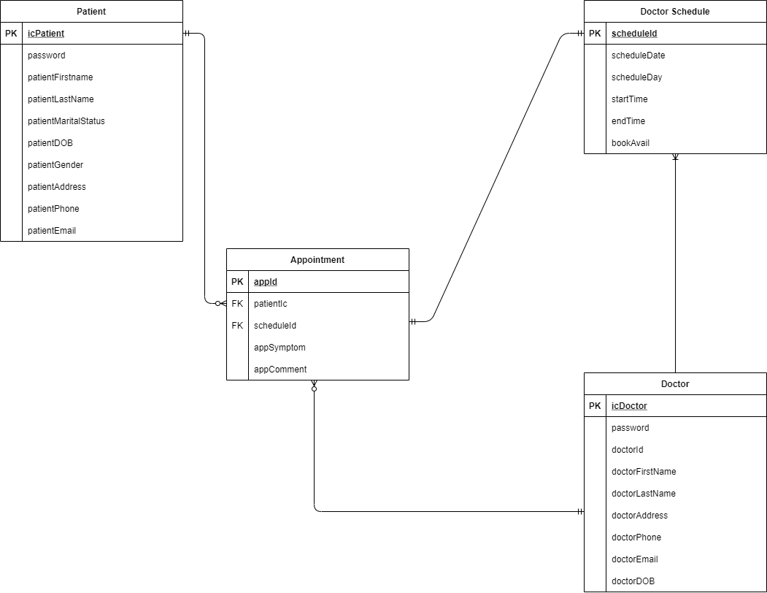

**QUERIES:**

SELECT * FROM `patient` WHERE `patientGender` = "female";

INSERT INTO `patient`(`icPatient`, `password`, `patientFirstName`, `patientLastName`, `patientMaritialStatus`, `patientDOB`, `patientGender`, `patientAddress`, `patientPhone`, `patientEmail`) VALUES ("050100","5100","Carlo","De Leon","Married","2000-05-01","Male","Lian","0955085484","cdeleon@gmail.com");

SELECT * FROM `doctorschedule` WHERE `bookAvail` = "notavail";

UPDATE `doctorschedule` SET `startTime`="07:00:00", `endTime`="07:30:00" WHERE `scheduleId`="46";

SELECT `doctorFirstName`, `doctorLastName` FROM `doctor` WHERE `doctorId` = "945";

UPDATE `doctor` SET `doctorPhone`="09659409605" WHERE `doctorId` = "945";

SELECT * FROM `appointment` WHERE `status` = "process";

UPDATE `appointment` SET `status`="done" WHERE `appId` = "88";